***Electrifying DR Congo: OSeMOSYS Model Documentation***

July 2022

**University of Cape Town – Energy Systems Research Group, Department of Chemical Engineering**

**Authors: Alison Hughes**

Table of Contents

Introductory Note 1

OSeMOSYS Model Sub-regions 2

Grid connected electricity demand in each sub-region 2

Electricity Demand profiles 3

Regional demand profiles 5

Grid electricity supply in each region 6

Existing grid network 6

Existing power plants 6

LCOE calculations for new power plants 7

Levelised cost and location of new hydro plants by type and region 9

Potential new hydro plants 9

Potential new wind plants 11

Potential new solar plants 14

Other plants 16

Data storage 17

Running the model 19

Scenarios 19

Results 20

Notes and reflections 20

# Introductory Note

This summary outlines the technologies, data and local regions that are currently represented in the OSeMOSYS model. The model has been developed to be flexible in terms of the number of power plants (of all types) that it can accommodate in each region as well as the number of years and number of timeslices in a year that can be modelled. The model period and all the technical plant parameters presented here are therefore fluid and can be updated and adjusted easily as needed. The Demand data shown is an output of OnSSET, adjusted in 2020 to match an estimate of electricity generated in that year. The representation of demand in the model, including the disaggregation of demand in each region into sub-sectors can be easily adjusted.

This document covers

* The sub-regions in the OSeMOSYS model, which currently represent the Eastern, Western and Southern grids. The Western and Eastern region and trade electricity through the DC transmission line which is currently in place. There is no trade of electricity between the Eastern region and either the Western or Southern region.
* The demand for grid connected electricity in the base year (2020) and an estimate of how this could grow until 2050. The growth between 2020 and 2030 is an output of OnSSET, after that it is projected based on an annual growth rate.
* Demand profiles for the electricity supplied to the sectors in each region represented in the model. These profiles dictate the capacity needed by the model to meet peak demand in each region. The profiles can be adjusted to represent the yearly increments (timeslices) in greater or lesser detail. The greater the detail the more accurately the model can account for aspects such as the variability of renewables over the course of the year, and any storage needed, however at the same time, increasing the number of timeslices in the year increases the time needed to generate and run the model.
* The existing grid network is used to allocate technologies in each region to the appropriate grid. The distance which site specific technologies lie from the grid also affects the capital costs assumed for each of the technologies on that grid that have a specific location. This applies to Wind, Solar and Hydro electric plants.
* Existing power plants are those that are currently commissioned and generating electricity. The capacity reflected on these plants only includes capacity that is currently operational and currently providing electricity to the DRC.
* LCOE estimates for wind, solar and hydro in each region are shown in order to show the regional differences in LCOE for each of these plant types, as well as the within region differences in LCOE between plant types. LCOE is a measure of the cost per kWh of electricity generated when plants are running at a certain capacity factor (capacity factor indicates the percentage of the year that the pant is generating electricity). This section only provides the cost of generating electricity ($/KWh) for plants running at full capacity factor.
* Examples of the wind and solar profiles for plants in each region over four periods, January to March, April to June, July to September and October to December.
* The data storage files
* Running the model

# OSeMOSYS Model Sub-regions

In OSeMOSYS, each region is modelled as a node. Within each node transmission and distribution lines connect power plants to the demand sectors.

Figure 1 shows the area covered by the three supply regions that are currently modelled namely, East, West and South. These regions have existing transmission and distribution networks. The capacity of the transmission and distribution grid is explicit, but they are not spatially represented. Additional regions can be added, in particular, a central region should be considered between the South and West regions.

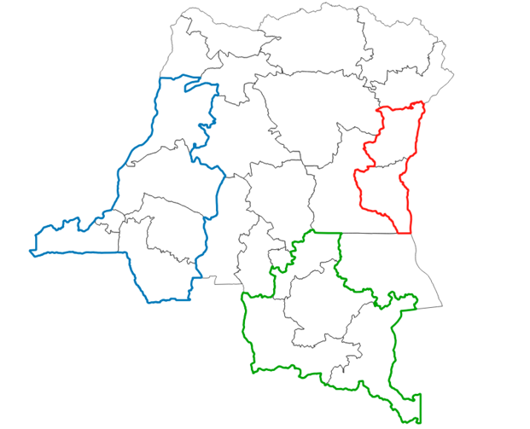

East

West

South

Figure 1: Model regions around the Western, Eastern and Southern Grid

# Grid connected electricity demand in each sub-region

In OSeMOSYS the demand for electricity is specified exogenously. Demand in OSeMOSYS can also be specified in term of a demand for energy services, which can account for the efficiency of electricity use to supply energy services using different technologies, for example supplying lighting with a CFL or a more efficient LED, however this requires substantial data that is not available for the DRC and the demand for electricity in all regions is specified in terms of the overall electricity used by the sectors in each region.

Total electricity supplied through the grid to the demand sectors in 2020 in the Western, Southerd and Eastern regions shown in Figure 1 is assumed to be 8800 GWh ( XX PJ) over all the regions. The electricity demand in 2030 shown in Figure 2 is the output of OnSSET scenarios L50,M50 and H50. This provides an example of the demand from OnSSET that is used as input for OSeMOSYS in 2030. In the current OSeMOSYS model, M50 is used as the reference case. The demand input to OSeMOSYS is easily adjusted to reflect any of the OnSSET scenario results. Beyond 2030 electricity demand is increased assuming an annual growth rate. These growth rates can be adjusted based on stakeholder feedback. The Health, education, commercial and agricultural sectors are currently summed in “other” (OTH). To split the demands further or aggregate them further is possible with some reworking of the data input file for each region.

Figure 2: OnSSET Demand for electricity in 2030 for sectors in each region in the L100 (low), M100 (medium) and H100 (high) Scenario

Figure 3: OSeMOSYS sectoral demand 2020 to 2050 M100 Scenario

Figure 4: OSeMOSYS demand 2020 to 2050 Low Medium and high demand scenarios in each region

## Electricity Demand profiles

An estimated demand profile is currently being used in OSeMOSYS for all three sectors. The overall demand profile differs slightly in each region, as the percentage of electricity used by the sectors differs in each region.

The sector profiles for each region provide an estimate of consumption in each hour of the year. In other words these data cover 8760 hours and sum to the overall electricity demand in the region over an annual period. The profile data is input into the model in an aggregate form, in order to reduce the time taken to complete a model run. The aggregate blocks of time that are used to represent the profile within the model are referred to as timeslices. Timeslice data input is flexible, currently four typical days representing four seasons, with ten timeslices each, are represented in the model. Previous model versions have included a 20 timeslice version and a six timeslice version to allow for faster testing of the model and scenarios. The way the model is set up the number of timeslices can be easily increased or decreased ie it is possible to have use combination of days and daysplits, however as these increase, the time needed for each model run increases substantially.

As can be seen in Figure 4 the profile of demand we are assuming for the residential sector varies the most during the day and peaks at around 8pm. The industrial sector profile is fairly flat, indicating that operations continue on a 24 hour basis. The commercial sector profile decreases significantly outside of the working day. These profiles demonstrate the importance of representing time of use demand in the model. The model must build sufficient capacity to satisfy the demand seen at peak periods which will be higher than the demand seen by the model if a flat profile was used for all three sectors.

Figure 5: Profiles for a typical day in January and a typical day in July as they are currently represented in the model

*Figure 4: Share of annual demand attributed to each timeslice in the 40 timeslice model (TS 01-40)*

## Regional demand profiles

Sectoral demand profiles (shown in Figure 5) combine to create the profiles shown in Figure 6. These profiles reflect the sectoral share of total demand in each region and change over time in the model as sectors grow at different rates. For example, the Southern region which has a higher share of industry, which has a flatter profile, has an overall flatter profile, whereas the eastern region which has a higher share of residential demand (see Figure 3) also has the highest peaks.

Figure 6: Timeslice profiles in the three regions.

The overall demand which the model must supply in each timeslice in 2020, resulting from these profiles, is shown in Figure 7. The Southern region has the highest overall demand, whilst demand in the east is fairly low. Although the timeslice profile in the east is the peakiest (see Figure 6), due to the overall low electricity demand in that region, it is the Western region which has the most variation in the overall demand profile. This implies that the Western region would benefit from a closer review of power station availability and storage in particular as large hydro investments could be made in that region.

Figure 7: Overall demand profile for in the three regions in 2020

# Grid electricity supply in each region

## Existing grid network

Transmission lines already in place (DC line not shown) and an area representing a 50km radius around these lines (known grid/microgrid networks) is shown in Figure 8. Only the plants shown in Table 1 are included as existing plants in each region. This will need to be adjusted as the grid expands.

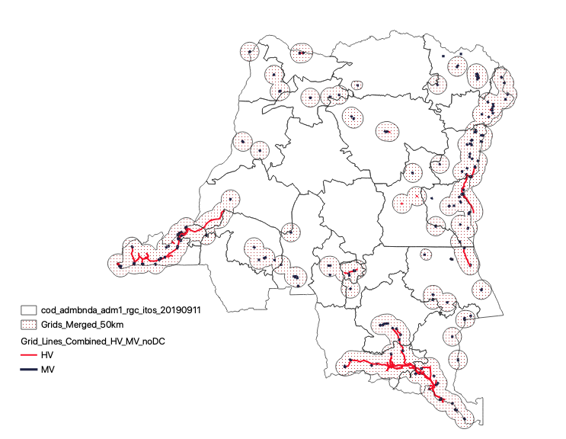

Figure 8: Estimate of HV and MV networks in DRC (excluding DC)

## Existing power plants

Data for existing plants is listed in the “power plant spreadsheet.xlsx”, in sheet “Existing”. This includes, plant name, capacity threshold, expected operational life, efficiency, minimum utilization assumptions and capacity and availability assumptions. A list of the existing, and currently operating, plants in the Western, Southern and Eastern regions that are included in the model is provided in Table 1.

Table 1: Existing (or committed) plants in each region

| **Latitude** | **Longitude** | **Region** | **Description** | **Name in model** | **Status** | **Capacity Threshold (GW)** |
| --- | --- | --- | --- | --- | --- | --- |
| -5.8487 | 13.0561 | West | Diesel Bomba/Muanda | D1DSBC01 | Existing | 0.023 |
| -5.51613 | 13.62162 | West | Hydro Inga1 | D1HYIC01 | Existing | 0.296 |
| -5.5269728 | 13.6209011 | West | Hydro Inga2 | D1HYIC02 | Existing | 1.056 |
| -5.82 | 13.48 | West | Hydro Zongo1 | D1HYZC01 | Existing | 0.031 |
| -4.770556 | 14.893889 | West | Hydro Zongo2 | D1HYZC02 | Existing | 0.150 |
| -4.841944 | 14.960556 | West | Hydro Sanga | D1HYSC01 | Existing | 0.000 |
| -10.499617 | 25.462471 | South | Hydro Busanga | D2HYBC01 | Existing | 0.060 |
| -10.7184 | 27.2839 | South | Hydro Koni | D2HYKC01 | Existing | 0.026 |
| -10.7452 | 27.2447 | South | Hydro Mwadingusha | D2HYMC01 | Existing | 0.000 |
| -10.5 | 25.4667 | South | Hydro Nzilo | D2HYKC02 | Existing | 0.100 |
| -10.3253 | 25.4277 | South | Hydro Nseke | D2HYKC03 | Existing | 0.186 |
| -1.6585 | 29.2205 | East | Diesel Bandundu | D3DSBC02 | Existing | 0.002 |
| -1.6585 | 29.2205 | East | Diesel Basankusu | D3DSBC03 | Existing | 0.001 |
| -1.6585 | 29.2205 | East | Diesel Boende | D3DSBC04 | Existing | 0.001 |
| -1.6585 | 29.2205 | East | Diesel Bumba | D3DSBC05 | Existing | 0.000 |
| -1.6585 | 29.2205 | East | Diesel Buta | D3DSBC06 | Existing | 0.002 |
| -1.6585 | 29.2205 | East | Diesel Butembo | D3DSBC07 | Existing | 0.000 |
| -1.6585 | 29.2205 | East | Diesel Gemena | D3DSGC01 | Existing | 0.000 |
| -1.6585 | 29.2205 | East | Diesel Goma | D3DSGC02 | Existing | 0.010 |
| -2.50833 | 28.86083 | East | Hydro Ruzizi 1 | D3HYRC01 | Existing | 0.010 |
| -2.50833 | 28.86083 | East | Hydro Ruzizi 2 | D3HYRC02 | Existing | 0.015 |
| -2.50833 | 28.86083 | East | Hydro Ruzizi III | D3HYRC03 | committed | 0.069 |
| -2.50833 | 28.86083 | East | Hydro Other small | D3HYOC01 | Existing | 0.022 |

## LCOE calculations for new power plants

Due to the large number of possible plants, LCOE estimates are used to filter or group the plants included in the model in each region. Those plants with the lowest LCOE are included in the model regions. For the PV and wind plants the LCOE calculations are as follows:

In the case of roads the capital cost is adjusted to account for the size of the plant, each 50MW increase in plant size doubles capital cost.

Data for levelized costs for PV and Wind including annual capacity factors at each site is sourced from IRENA (personal communication). RE LCOE is dominate by the plant costs. Data for Hydro is from SHER. Costs for Hydro, wind and solar includes upgrading transmission infrastructure.

LCOE for wind and solar are based on the costs in Table 2.

Table 2: LCOE Costs for wind and solar

|  |  |  |
| --- | --- | --- |
|  | **Wind** | **Solar** |
| Plant Availability Factor 100m (cf) | Average of 8760 hours of CF data provided by IRENA for each area | Average of 8760 hours of CF data provided by IRENA for each area |
| Plant Capacity factor for each TS | Calculated using IRENA hourly profiles | Calculated using IRENA hourly profiles |
| Plant Capital Cost (Cc) IRENA | 1 700 Class 3  1 250 Class 1 | 1500 (USD/kW)1 |
| Plant Fixed O&M | 60 | 50 (USD/kW/yr) |
| Plant Variable O&M | 0 | 4 (USD/kWh) |
| Transmission Substations | 71 000 | 71 000 (USD) |
| Transmission line | 0.990 | 0.990 (USD/kW/km) |
| Road | 407 000 | 407 000 (USD/km) |
| Transmission line lifetime | 40 | 40 |
| Road lifetime | 25 | 25 |
| Plant lifetime | 25 | 25 |

*Data sources:*

*1 Estimated likely cost based on LBNL/IRENA analysis*

The capital and maintenance costs of hydro electric plants use the estimates obtained from the SHER report “*Priorisation des sites hydroélectriques et solaires : Rapport d’analyse”.*

## Levelised cost and location of new hydro plants by type and region

The distribution of hydro plants considered in the model is shown in Figure 9. Hydro plants are grouped into small, medium and large, small <20MW, medium 20-100MW, and large >100MW. The plants with the lowest levelized cost in each size are included in the model in each region.

### Potential new hydro plants

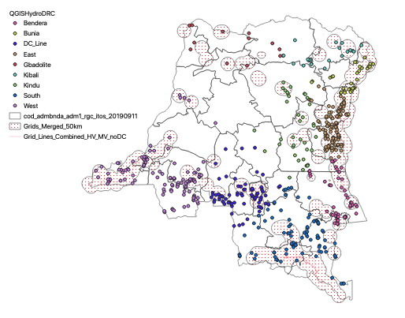

Figure 9: Regional Location of all the new hydro plants considered (source SHER)

There is a wide range in the levelized cost of electricity between plants of different sizes and in different regions. Figure 10 shows the LCO of small, medium and large plants considered in each region plotted against the size of the plant. It demonstrates a general drop in LCOE as plant size increases, for example showing that the LCOE of the larger hydro plants considered in the West is well below that of the small and medium plants in that region, and below that of the larger plants considered in the Southern and Eastern region.

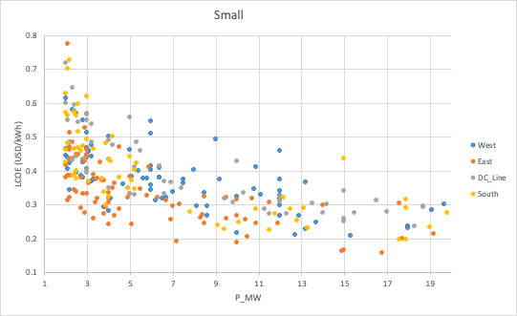

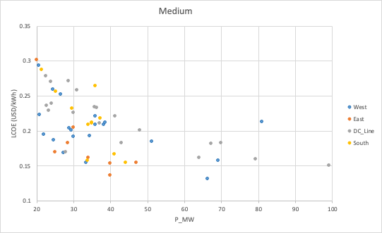

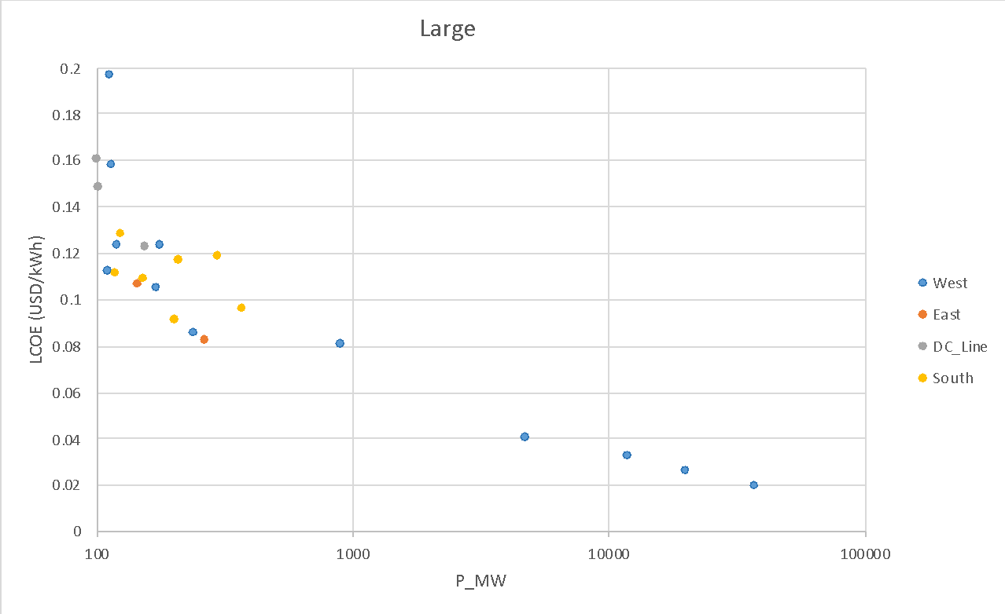

Figure 10: LCOE comparison of small, medium and large power plants in the three regions (data source SHER)

The final list of plants included in the model in each region is filtering based on levelized cost, currently only plants with an LCOE of <250 $/MWh are included. This threshold can be changed and input spreadsheets will update automatically.

Figure 11: Location of new small, medium and large hydro plants included in the model (after filtering) (Data Source SHER)

The total new capacity of small, medium and large hydro in each region is shown in Table 2. The large hydro in the Western region includes Grand Inga. Each plant is represented individually in the model and more information on each of the hydro plants, including their costs and capacities, can be found in “power plant database.xlsx”.

### Potential new wind plants

The LCOE and capacity factors used in the model in each region are for a class 3 wind turbine with a 100m hub height and were provided by IRENA. Wind sites across each region have been clustered according to group those with similar wind profiles. This is done to reduce the number of technologies represented in the model, but retain representative costs and capacity factors for a selection of sites in each region.

Given infrastructure restrictions, planning for class 1 turbines may be more appropriate. Class 1 capacity factors are estimated for all regions using the following assumptions to derate capacity. The exact difference in output from class I to class III is site specific, but downrating the class III capacity factor by 0.795 to get to class I provides a fair approximation[1].

The capacity factors vary widely between the eastern and South and Western Regions. Capacity factors in the East are very low, and in this region wind is unlikely to be competitive with other technologies. In the West and South capacity factors are higher, particularly in the South where they reach up to 0.37. A summary of the capacity factors, maximum capacity for each region and LCOE at maximum capacity factor is shown in Table 2.

Two, seven and three typical plants are included in the model in the Western, Southern and Eastern region respectively. These plants represent grouped locations with similar wind profiles. Figure 9 shows the wind profiles associated with each of these plants, Table 1 lists the plant characteristics.

Table 4: Characteristics of wind plants in OSeMOSYS regions

|  |  |  |  |
| --- | --- | --- | --- |
|  | **Zone Capacity Factor 100m** | **Max Capacity (MW)** | **LCOE (USD/kWh)** |
| West 1 | 33.2 | 128.1 | 0.0899 |
| West 2 | 35.5 | 198.2 | 0.0949 |
| South 1 | 36.6 | 70.1 | 0.0867 |
| South 2 | 35.2 | 72.4 | 0.0927 |
| South 3 | 34.9 | 24.7 | 0.0932 |
| South 4 | 35.2 | 78.3 | 0.0902 |
| South 5 | 36.9 | 129.5 | 0.0889 |
| South 6 | 37 | 313 | 0.0896 |
| South 7 | 37.5 | 82.7 | 0.0836 |
| East 1 | 13.3 | 24.8 | 0.2708 |
| East 2 | 9.9 | 23.8 | 0.3838 |
| East 3 | 8.4 | 84 | 0.4688 |



Figure 12: Typical Profiles for “best” plants at 100m hub height class 3 turbine in the West, South and East.

### Potential new solar plants

PV options with plant specific PV profiles and costs are included in each region.

Figure 13: Solar Capacity factors across the DRC

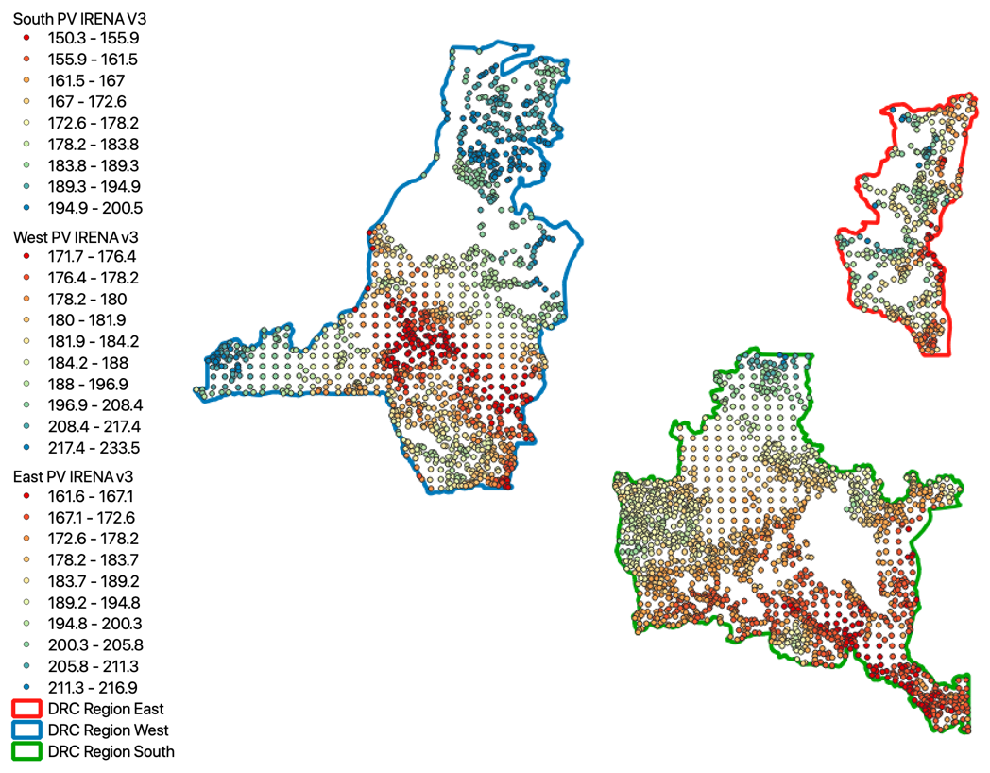

Figure 14: Solar LCOE within regions (USD/MWh)

Eight representative plants are included in the Western and Southern region, whilst only three plants are included in the Eastern region.

Table 5: Characteristics of Solar plants in OSeMOSYS regions

|  |  |  |  |
| --- | --- | --- | --- |
|  | **Zone Capacity Factor 100m** | **Max Capacity (MW)** | **LCOE (USD/kWh)** |
| West 1 | 18.97 | 77 | 0.1286 |
| West 2 | 19.01 | 556 | 0.1292 |
| West 3 | 18.87 | 345 | 0.1295 |
| West 4 | 18.88 | 1198 | 0.1303 |
| West 5 | 18.9 | 87 | 0.1309 |
| West 6 | 18.83 | 690 | 0.1310 |
| West 7 | 18.87 | 1473 | 0.1314 |
| West 8 | 18.82 | 300 | 0.1320 |
| South 1 | 21.68 | 24 | 0.1121 |
| South 2 | 21.66 | 2935 | 0.1136 |
| South 3 | 21.65 | 383 | 0.1141 |
| South 4 | 21.7 | 1417 | 0.1148 |
| South 5 | 21.47 | 1144 | 0.1147 |
| South 6 | 21.52 | 2189 | 0.1152 |
| South 7 | 21.64 | 1862 | 0.1159 |
| South 8 | 21.34 | 472 | 0.1156 |
| East 1 | 19.77 | 334 | 0.1199 |
| East 2 | 20.08 | 961 | 0.1187 |
| East 3 | 20.22 | 40 | 0.1165 |



Figure 15: Typical profile for “best” plants in the West, South and Eastern regions

### Other plants

New generic plant options included are diesel, HFO, Gas, OCGT, Bagasse and wood. Coal, nuclear and solar thermal with co-firing are not included as an option as at this point.

# Data storage

Numerous files are currently used to store the data input needed. The flow of data into the model is presented in Figure 15, the files used to store the data in raw, processed and model ready formats are listed in Table 3.

All raw data, eg

Plant profiles

Processed data

Power plant database

Demand profiles for 3 regions

Solar profiles for 3 regions

Wind profiles for 3 regions

OSeMOSYS data input workbooks

Python code

Coded text files for OSeMOSYS runs

Figure 16: Flow of information from raw data to coded text files for OSeMOSYS

Table 6: Excel data and model workbooks

| **Data type** | **Excel workbook name** | **Description of data** | **Source** |
| --- | --- | --- | --- |
| Full set of Hydro power plant data | Hydro_points_with_additional_info_v2 | Geographic location of plants with all hydro input parameters including LCOE | SHER |
| Full set Wind plants | QGIS_All_IRENA_Wind | Geographic location of plants with size, capacity factor, LCOE | IRENA |
| Full set Solar plants | QGIS_All_IRENA_PV | Geographic location of plants with size, capacity factor, LCOE | IRENA |
| Power plant technology characteristics | Power plant database | Summary of existing plants, new generic plants and new hydro and wind and solar plants in each region that are included in the model | Several (indicated in spreadsheet) |
| OSeMOSYS data input for each region 20 TS model, 2020-2040 | DRC_input_data_West_V3  DRC_input_data_East_V3  DRC_input_data_South_V3 |  | Own |
| OSeMOSYS data input for each region 40 TS model, 2020-2050 | DRC_input_data_West_V350_4_10s  DRC_input_data_East_V350_4_10  DRC_input_data_South_V350_4_10s |  | Own |
| Electricity Demand data | Separate files for East, South and West, mid, low and high growth scenarios (9 files total) | Annual | OnSSET |
| Electricity profile data | Demand profiles for 3 regions |  | UCT |
| Profile data for demand | Demand profiles for 3 regions | Hourly data and aggregated timeslice data for OSeMOSYS | IRENA/UCT |
| Profile data for solar | Solar profiles for 3 regions | Hourly data and aggregated timeslice data for OSeMOSYS | IRENA/UCT |
| Profile data for wind | Wind profiles for 3 regions | Hourly data and aggregated timeslice data for OSeMOSYS | IRENA/UCT |

Data for each model region is stored in sheets within each of theregional input spreadsheets are named according to the OSeMOSYS sets or parameter they provide data to, with the exception of timeslice and yearsplit.

# Running the model

Python script is used to extract the data from the regional spreadsheets and write it into text files in the format required by OSeMOSYS. The name of the text file and the input data file are specified in the code. Two versions of the python code allow either

1. The generation of an OSeMOSYS input file for each region individually
2. The generation of an OSeMOSYS input file for the Western and Southern region combined with transmission capacity between these regions.

The python files can be adjusted to generate the correct number of years and timeslices for each model run.

OSeMOSYS is open source and the code can be downloaded from [www.osemosys.org](http://www.osemosys.org). The OSeMOSYS code used to write the summary output from each model run was adjusted to write the results in a way that was easier to work with.

# Scenarios

The scenario data can be changed in the “scenario” sheet of the “power plant database” workbook. For model testing purposes changes were made to costs, demand in all regions and to include or exclude Inga IV. Fuel costs were increased, solar and wind costs were reduced to reflect the current trends. The scenarios that are pre-loaded into the “power plant database” scenario workbook are shown in Table 4.

Table 7: Scenarios included in the final model runs

|  |  |  |  |  |  |  |  |
| --- | --- | --- | --- | --- | --- | --- | --- |
| Scenario | Mid demand | Low demand | High demand | Inga IV included (does not apply to Eastern Region) | PV and wind costs lower range (IEA/IRENA) | Gas and Diesel costs (x1.25) | Gas and Diesel costs (x1.5) Applied to Eastern Region only |
| 1 | X |  |  |  |  |  |  |
| 2 |  | x |  |  |  |  |  |
| 3 |  |  | X |  |  |  |  |
| 4 | X |  |  | X |  |  | X |
| 5 | X |  |  |  | X |  |  |
| 6 | X |  |  |  |  | X |  |
| 7 | X |  |  |  | X | X |  |
| 8 | X |  |  | X | X | X | X |

The demand scenarios show the capacity needs at different levels of electrification ambition.

Indications are that PV and wind costs which are IRENA are already too high, and the lower capital cost used for these technologies in scenario 5,7 and 8 allow the influence of these cost assumptions on the optimal power plant mix to be tested. Inga IV is the lowest cost option for electricity supply in the Western Region, however Inga IV is not included by default due to environmental and other concerns around it’s construction. Including Inga IV allows us to test the extent to which the capacity expansion or supply cost changes when it is included. Gas and diesel costs are very uncertain and testing the sensitivity of both the expansion plan and production of electricity from these plants is therefore considered important.

# Results

Each model run creates a .csv file of summary results showing electricity demand, total capacity, new capacity additions, production from each technology in each timeslice. The model run also generates a larger set of results for all parameters in the model.

# Notes and reflections

The model runs conducted show that the availability and cost of renewables will play an important role in a least cost electrification plan for DRC. Similarly the availability of hydro, and storage capacity of dams is important.

The timing of plants, and the assumption around the first year in which new plants can be commissioned, is currently playing a large role in the choice of plants in the early years. It is therefore important that this is not over optimistic or pessimistic, and that demand in the early years is accurate. These early capacity expansions remain in the model and influence capacity expansion in future years, and as the system is quite constrained in terms of the electricity that can be supplied to meet demand until 2025, it is important that the model reflects, rationally, what is possible.

Future iterations of the model should focus on

1. Stakeholder engagement to validate the parameters used in the model such as the first investment year and annual capacity expansion of new plant options
2. Stakeholder engagement to review wind and solar costs in each region to better reflect current trends and challenges
3. Stakeholder engagement to verify cost assumption and scenarios for fossil fuels
4. Expansion of the plant options to allow for geothermal plants
5. Expansion of the plant options to including solar thermal plants with storage. As these plants are currently expensive and storage in DRC is available through hydro these plants were not prioritized in phase 2, however costs are decreasing and a review of these plants should be completed for future iterations.
6. A review of the seasonal availability of hydro plants, particularly reflecting storage capacity of dams, and cascading hydro in each region.
7. Increasing the geographic area of each region to mirror grid expansion in OnSSET. As new plants expansion is limited to those within each geographic zone, this will allow more plant options to be included in the model to reflect the increase in possibilities (or links between existing grids) as grid expansion occurs, particularly the region between the Southern and Western regions.
8. An open source user interface is being developed for OSeMOSYS that will allow intermediate level modellers to adapt and run the three regional models. For example, if the models were captured in the interface, it would not be necessary to maintain and run the python code; adjustments to the parameters in the model could be made more easily and; the model could be debugged more easily. Accessibility to the model for DRC stakeholders will increase and it will speed up time needed to develop and test additional model regions and scenarios

1. [https://www.researchgate.net/publication/352324847_Resource_Assessment_of_Wind_Energy_Potential_of_Mokha_in_Yemen_with_Weibull_Speed](https://protect-za.mimecast.com/s/-ZR9C1jp84SWkzpNiLhtJi)